University of Cebu-Banilad

College of Computer Studies

IT-ELPHP

Lec- 12:30-1:30 PM

Lab- 1:30-4:30 PM

IT-ELDROID

Lec- 7:30-9:30 PM

Lab- 4:30-7:30 PM

**Carpenter’s Choice**

Submitted by:

Ivan Trapero

Rob Cabahug Yu

Christopher Reales

Victor Ymbong

Kim Baring

Godwin Enriquez

Submitted to:

Mr. Richyll Son

**Overview**

Carpenter’s Choice is a mobile application designed to streamline and enhance the woodworking industry by providing an all-in-one platform for tool rentals and purchases. Whether you are a professional carpenter, a DIY enthusiast, personal use, or a construction business owner, ensures that you have easy access to the tools you need, precisely when you need them.

At its core, Carpenter’s Choice functions as a dynamic marketplace where users can rent or buy a wide range of high-quality tools and equipment. The application eliminates the hassle of searching for tools by offering a centralized hub where availability, pricing, and rental durations are transparent and easy to manage. With its user-friendly interface, Carpenter’s Choice simplifies the process of acquiring tools, whether for short-term projects or long-term investments.

Beyond its marketplace capabilities, Carpenter’s Choice is equipped with advanced features designed to optimize the user experience and improve workflow efficiency. Real-time inventory tracking allows users to check tool availability instantly, while a secure reservation system ensures that users can lock in the tools they need without delays. Additionally, the platform offers flexible rental options, allowing users to select timeframes that align with their project timelines.

For suppliers and tool owners, Carpenter’s Choice presents an opportunity to monetize idle equipment by listing their tools for rent or sale. The seller program provides exposure to a broader audience, enabling businesses and individual owners to maximize their revenue potential. With an integrated rating and review system, users can make informed decisions based on community feedback, ensuring reliability and quality.

Carpenter’s Choice is more than just a transactional platform; it is a digital ecosystem that fosters efficiency and collaboration within the woodworking and construction sectors. The app integrates seamless logistics solutions, ensuring on-time tool deliveries and pickups, reducing downtime, and enhancing project productivity. Additionally, it promotes sustainable practices by encouraging tool sharing, reducing unnecessary purchases, and minimizing resource waste.

By harnessing the power of technology, Carpenter’s Choice envisions a future where woodworkers, builders, and craftsmen have immediate, hassle-free access to the tools they need to bring their projects to life. The application empowers professionals and hobbyists alike to work smarter, reduce costs, and embrace a more efficient approach to tool management. With Carpenter’s Choice, the right tools are always within reach, helping users achieve precision, creativity, and excellence in every project.

**Entity Relationship Diagram**

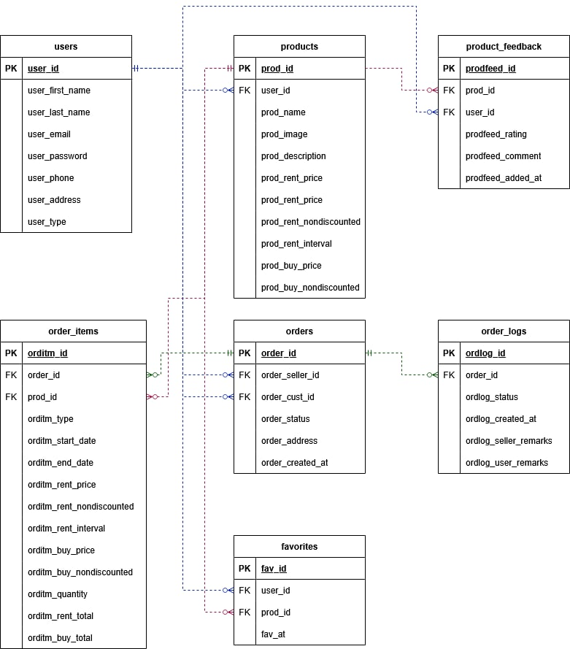

**Use Case**

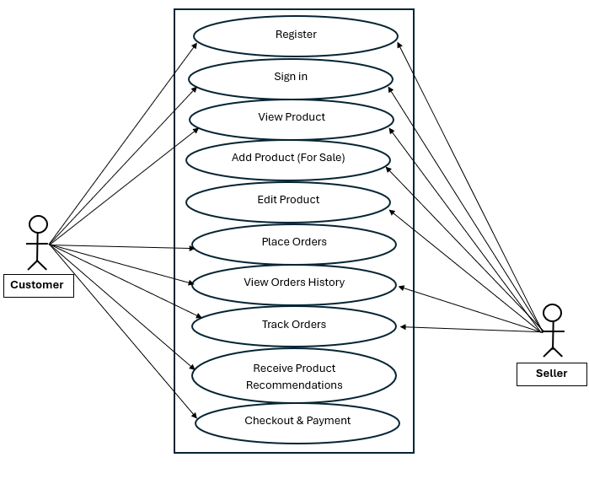

**Database Design**

An overview of every database table is provided in this section, along with the Table Name, Description, Null, Field Name, Data Type, and Field Size.  
  
 **Users**

| **Column Name** | **Data Type** | **Constraints** | **Description** |
| --- | --- | --- | --- |
| **User_ID** | **INT** | **PRIMARY KEY,**  **AUTO_INCREMENT** | **Unique identifier of the table** |
| **User_FirstName** | **VARCHAR(50)** | **NOT NULL** | **First name of the user** |
| **User_LastName** | **VARCHAR(50)** | **NOT NULL** | **Last name of the user** |
| **User_Email** | **VARCHAR(100)** | **UNIQUE, NOT NULL** | **Email of the user** |
| **User_Password** | **VARCHAR(50)** | **NOT NULL** | **Password of the user** |
| **User_PhoneNo** | **INT** | **UNIQUE, NOT NULL** | **Phone Number of the user** |
| **User_Address** | **VARCHAR(255)** | **UNIQUE, NOT NULL** | **Address of the user** |
| **User_Type** | **VARCHAR(200)** | **NOT NULL** | **User type** |

**Product**

| **Column Name** | **Data Type** | **Constraints** | **Description** |
| --- | --- | --- | --- |
| **ProductID** | **INT** | **PRIMARY KEY,**  **AUTO_INCREMENT** | **Unique identifier of the table** |
| **User_ID** | **INT** | **FOREIGN KEY (User.userID)** | **Unique identifier of the table** |
| **Product_Name** | **VARCHAR(100)** | **NOT NULL** | **Name of the Product** |
| **Product_Image** | **VARCHAR(100)** | **NOT NULL** | **Image of the product** |
| **Product_ Description** | **VARCHAR(100)** | **NOT NULL** | **Description of the product** |
| **Product_Rent_Price** | **INT** | **NOT NULL** | **Rent Price of the product** |
| **Product_Rent_Nondiscounted** | **VARCHAR(100)** | **NOT NULL** | **Not discounted Product Rented** |
| **Product_Rent_Interval** | **VARCHAR(100)** | **NULL** | **Interval of the Product Rented** |
| **Product_Buy_Price** | **INT** | **NOT NULL** | **Price of the Buy Product** |
| **Product_Buy_Nondiscounted** | **VARCHAR(100)** | **NOT NULL** | **Not discounted Price of the bought product** |

**Product Feedback**

| **Column Name** | **Data Type** | **Constraints** | **Description** |
| --- | --- | --- | --- |
| **ProductFeed_ID** | **INT** | **PRIMARY KEY,**  **AUTO_INCREMENT** | **Unique identifier of the table** |
| **Product_ID** | **INT** | **FOREIGN KEY (Product.productID)** | **Unique identifier of the table** |
| **User_ID** | **INT** | **FOREIGN KEY (User.userID)** | **Unique identifier of the table** |
| **ProductFeed_Rating** | **VARCHAR(100)** | **NOT NULL** | **Rating of the Product Feedback** |
| **ProductFeed_Comment** | **VARCHAR(100)** | **NOT NULL** | **Comment of the Product Feedback** |
| **ProductFeed_Added_At** | **VARCHAR(100)** | **NOT NULL** | **Added of the Product Feedback** |

**Order_Items**

| **Column Name** | **Data Type** | **Constraints** | **Description** |
| --- | --- | --- | --- |
| **OrderItem_ID** | **INT** | **PRIMARY KEY,**  **AUTO_INCREMENT** | **Unique identifier of the table** |
| **Order_ID** | **INT** | **FOREIGN KEY (Order.orderID)** | **Unique identifier of the table** |
| **Product_ID** | **INT** | **FOREIGN KEY (Product.productID)** | **Unique identifier of the table** |
| **OrderItem_Type** | **VARCHAR(100)** | **NOT NULL** | **Type of order Item** |
| **OrderItem_Start_Date** | **VARCHAR(200)** | **NULL** | **Date starts of Order Item** |
| **OrderItem_End_Date** | **VARCHAR(100)** | **NULL** | **Date End of Order Item** |
| **OrderItem_Rent_Price** | **INT** | **NOT NULL** | **Rent Price of Order Item** |
| **OrderItem_Rent_Nondiscounted** | **INT** | **NOT NULL** | **Not discounted Rent Order Item** |
| **OrderItem_Rent_Interval** | **VARCHAR(100)** | **NOT NULL** | **Interval of the Rent Order Item** |
| **OrderItem_Buy_Price** | **INT** | **NOT NULL** | **Buy Price of the Order Item** |
| **OrderItem_Buy_Nondiscounted** | **INT** | **NOT NULL** | **Not discounted Buy Price of Order Item** |
| **OrderItem_Quality** | **VARCHAR(100)** | **NOT NULL** | **Quality of the Order Item** |
| **OrderItem_Rent_Total** | **INT** | **NOT NULL** | **Total Rent of the Order Item** |
| **OrderItem_Buy_Total** | **INT** | **NOT NULL** | **Total Buy of the Order Item** |

**Orders**

| **Column Name** | **Data Type** | **Constraints** | **Description** |
| --- | --- | --- | --- |
| **Order_ID** | **INT** | **PRIMARY KEY,**  **AUTO_INCREMENT** | **Unique identifier of the table** |
| **Order_Seller_ID** | **INT** | **FOREIGN KEY (Seller.sellerID)** | **Unique identifier of the table** |
| **Order_Cust_ID** | **INT** | **FOREIGN KEY (Cust.custID)** | **Unique identifier of the table** |
| **Order_Status** | **VARCHAR(200)** | **NOT NULL** | **Status of the Order** |
| **Order_Address** | **VARCHAR(200)** | **FOREIGN KEY (User.userID)** | **Address of the Order** |
| **Order_Created_at** | **VARCHAR(200)** | **FOREIGN KEY (BuyItem.buyitemID)** | **Created of the Order** |

**Order_Logs**

| **Column Name** | **Data Type** | **Constraints** | **Description** |
| --- | --- | --- | --- |
| **Orderlog_ID** | **INT** | **PRIMARY KEY,**  **AUTO_INCREMENT** | **Unique identifier of the table** |
| **Order_ID** | **INT** | **FOREIGN KEY (Order.orderID)** | **Unique identifier of the table** |
| **Orderlog_Status** | **VARCHAR(100)** | **NOT NULL** | **Status of the Order** |
| **Orderlog_Created_at** | **VARCHAR(100)** | **NOT NULL** | **Order Created at** |
| **Orderlog_Seller_Remarks** | **VARCHAR(100)** | **NOT NULL** | **Seller Remarks of the Orderlog** |
| **Orderlog_User_Remarks** | **VARCHAR(100)** | **NOT NULL** | **User Remarks of the Orderlog** |

**Favorites**

| **Column Name** | **Data Type** | **Constraints** | **Description** |
| --- | --- | --- | --- |
| **Favorites_ID** | **INT** | **PRIMARY KEY,**  **AUTO_INCREMENT** | **Unique identifier of the table** |
| **User_ID** | **INT** | **FOREIGN KEY (User.userID)** | **Unique identifier of the table** |
| **Product_ID** | **INT** | **FOREIGN KEY (Product.productID)** | **Unique identifier of the table** |
| **Favorites_at** | **VARCHAR(100)** | **NOT NULL** | **Favorites Item** |

**Seller**

| **Column Name** | **Data Type** | **Constraints** | **Description** |
| --- | --- | --- | --- |
| **SellerID** | **INT** | **PRIMARY KEY,**  **AUTO_INCREMENT** | **Unique identifier of the table** |
| **FirstName** | **VARCHAR(100)** | **NOT NULL** | **First Name of the Seller** |
| **LastName** | **VARCHAR(100)** | **NOT NULL** | **Last Name of the Seller** |
| **Email** | **VARCHAR(100)** | **NOT NULL** | **Email of the Seller** |
| **PhoneNo** | **VARCHAR(50)** | **NOT NULL** | **Phone Number of the Seller** |
| **Address** | **VARCHAR(100)** | **NOT NULL** | **Address of the Seller** |
| **Rating** | **VARCHAR(200)** | **NULL** | **Rating of the Seller** |

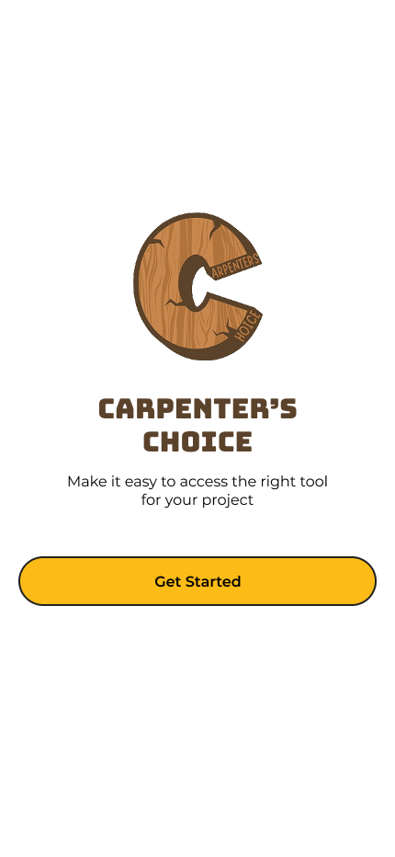UI Design

|  | Name | Description | Parameter | Action |
| --- | --- | --- | --- | --- |
| 1 | Carpenter’s Choice Logo | ImageView of the logo of Carpenter’s Choice | android:src="@drawable/carpenters_choice_logo" |  |
| 2 | Carpenter’s Choice Slogan | TextView of the Carpenter’s Choice Slogan saying “Make it easy to access the right tool for your project” | android:text="@strings/carpenters_choice_slogan" |  |
| 3 | Get Started Button | Yellow button with the text “Get Started” | android:background="@colors/primary"  android:text=@strings/get_started_cta" | Leads to Login Activity |

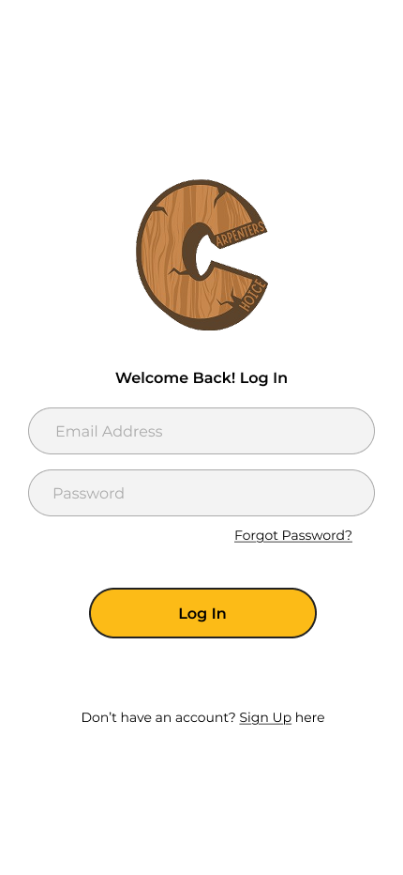

|  | Name | Description | Parameter | Action |
| --- | --- | --- | --- | --- |
| 4 | Carpenter’s Choice Logo | ImageView of the logo of Carpenter’s Choice without the text | android:src="@drawable/carpenters_choice_logo_no_text" |  |
| 5 | Welcome Back Message | TextView that says “Welcome Back! Log In” | android:text="@strings/decor_welcome_back" |  |
| 6 | Email Address Field | EditText for inputting user’s email address | android:hint="@strings/placeholder_email"  android:inputType="textEmailAddress" |  |
| 7 | Password Field | EditText for inputting user’s password | android:hint="@strings/placeholder_password"  android:inputType="textPassword" |  |
| 8 | Forgot Password Link | Underlined link with text “Forgot Password” | android:text="@strings/link_forgot_password"  android:textColorLink="@colors/mono_lgray" | Leads to Forgot Password Activity |
| 9 | Login Button | Button with the text “Log In” | android:text="@strings/btn_login"  android:background="@colors/primary" |  |
| 10 | Sign Up Link | Link with text “Don’t have an account? Sign Up here” | android:text="@strings/link_signup"  android:textColorLink="@colors/mono_black" | Leads to Sign Up Activity |

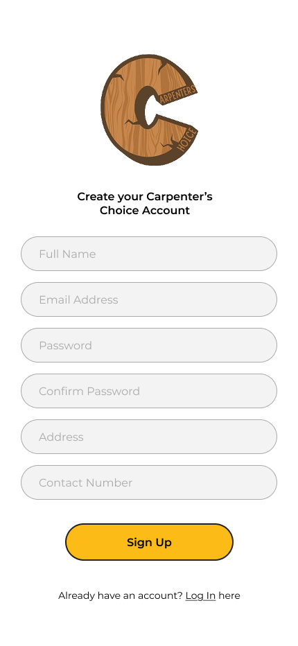

|  | Name | Description | Parameter | Action |
| --- | --- | --- | --- | --- |
| 11 | Carpenter’s Choice Logo | ImageView of the logo of Carpenter’s Choice without the text | android:src="@drawable/carpenters_choice_logo_no_text" |  |
| 12 | Welcome Message | TextView that says “Create your Carpenter’s Choice Account” | android:text="@strings/decor_welcome_back” |  |
| 13 | Full Name Field | EditText for inputting user’s full name | android:hint="@strings/placeholder_fullname"  android:inputType="textPersonName" |  |
| 14 | Email Address Field | EditText for inputting user’s email address | android:hint="@strings/placeholder_email"  android:inputType="textEmailAddress" |  |
| 15 | Password Field | EditText for inputting user’s password | android:hint="@strings/placeholder_password"  android:inputType="textPassword" |  |
| 16 | Confirm Password Field | EditText to confirm user’s password | android:hint="@strings/placeholder_confirm password"  android:inputType="textPassword" |  |
| 17 | Address Field | EditText for inputting user’s complete address | android:hint="@strings/placeholder_address"  android:inputType="textPostalAddress" |  |
| 18 | Contact Number Field | EditText for inputting user’s contact number | android:hint="@strings/placeholder_phone"  android:inputType="phone" |  |
| 19 | Sign Up Button | Button with the text “Sign Up” | android:text="@strings/btn_signup"  android:background="@colors/primary” | Creates an account and redirects the user to dashboard |
| 20 | Log In Link | Link with text “Already have an account? Log In here” | android:text="@strings/link_login"  android:textColorLink="@colors/mono_lgray" | Leads to Log In Activity |

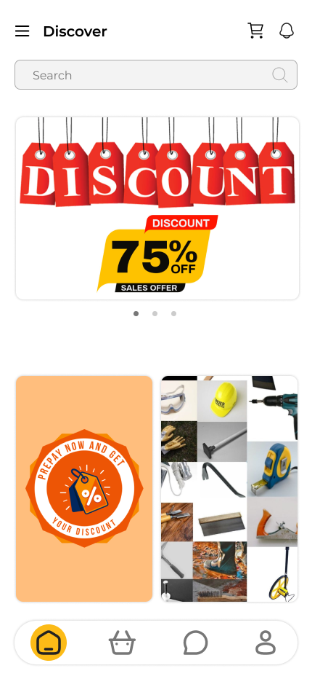

|  | Name | Description | Parameter | Action |
| --- | --- | --- | --- | --- |
| 21 | Sidebar Navigation Button | ImageButton with the hamburger icon | android:src="@drawable/ic_hamburger"  android:contentDescription="@string/decor_nav_button" | Opens up the sidebar navigation |
| 22 | Discover | TextView for the page title | android:text="@string/pagetitle_discover" |  |
| 23 | Cart Button | ImageButton with the shopping cart icon | android:src="@drawable/ic_cart"  android:contentDescription="@string/link_cart" | Leads to Cart Activity |
| 24 | Notifications Button | ImageButton with bell icon | android:src="@drawable/ic_bell"  android:contentDescription="@string/link_notifications" | Leads to Notification Activity |
| 25 | Search Field | EditText for searching products. Contains placeholder text “Search” | android:hint="@string/placeholder_search"  android:inputType="textAutoComplete" | On input, displays all the products matching the keyword |
| 26 | Primary Promotions Area | ImageView that slideshows product promotions and discounts | android:contentDescription="@string/decor_promo_primary"  android:scaleType="centerCrop" |  |
| 27 | Secondary Promotions Area | ImageView that slideshows product promotions and discounts | android:contentDescription="@string/decor_promo_secondary"  android:scaleType="centerCrop" |  |
| 28 | Home Button - Bottom Navigation | ImageButton with a home icon and yellow background that indicates active state | android:src="@drawable/ic_home"  android:background="@drawables/borders_round_full"  android:backgroundTint="@colors/primary"  android:contentDescription="@string/btmnav_home" | Leads to Dashboard Screen |
| 29 | New Arrivals Button - Bottom Navigation | ImageButton with a basket icon | android:src="@drawable/ic_basket"  android:contentDescription="@string/btmnav_new_arrivals" | Leads to New Arrivals Screen |
| 30 | Messages Button - Bottom Navigation | ImageButton with a message bubble icon | android:src="@drawable/ic_message"  android:contentDescription="@string/btmnav_messages" | Leads to Messages Screen |
| 31 | Account Button - Bottom Navigation | ImageButton with a user icon | android:src="@drawable/ic_user"  android:contentDescription="@string/btmnav_account" | Leads to Account Screen |

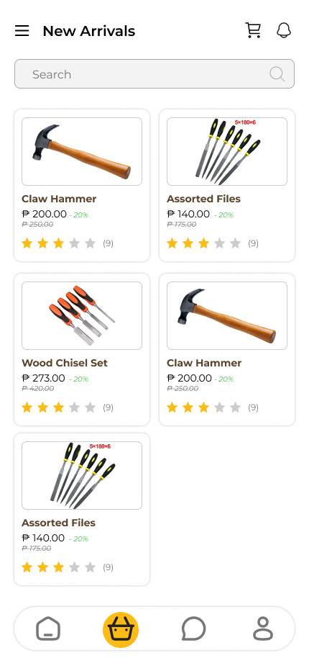

|  | Name | Description | Parameter | Action |
| --- | --- | --- | --- | --- |
| 32 | Search Field | EditText for searching products. Contains placeholder text “Search” | android:hint="@string/placeholder_search"  android:imeOptions="actionSearch" | On input, displays all the products matching the keyword |
| 33 | Products Recycler View | RecyclerView that displays all the featured products or products that matched the search | app:spanCount="2"  android:clipToPadding="false" |  |
| 34 | Product Container | LinearLayout that holds the product information | android:background="?selectableItemBackground"  android:orientation="vertical" | Leads to Product Activity with chosen product’s information |
| 35 | Product Image - Product Container | ImageView that shows product image | android:scaleType="centerCrop"  android:contentDescription="@string/decor_product_image" |  |
| 36 | Product Name - Product Container | TextView that displays the product name | android:textSize="14sp"  android:maxLines="2" |  |
| 37 | Product Price - Product Container | TextView that shows product price | android:textColor="@colors/primary"  android:textSize="16sp" |  |
| 38 | Product Discount - Product Container | TextView in green color that shows product discount | android:textColor="@color/green"  android:background="@drawable/bg_discount_badge" |  |
| 39 | Product Original Price - Product Container | TextView with strikethrough line that shows product’s original price before discount | android:paintFlags="strikeThruText"  android:textSize="12sp" |  |
| 40 | Product Star Ratings - Product Container | ImageView of star icons that show the average star rating of product | android:src="@drawable/ic_stars_4" (dynamic) |  |
| 41 | Product Feedback Counter- Product Container | TextView that shows how many users rated the product | android:textSize="12sp"  android:textColor="@color/gray" |  |

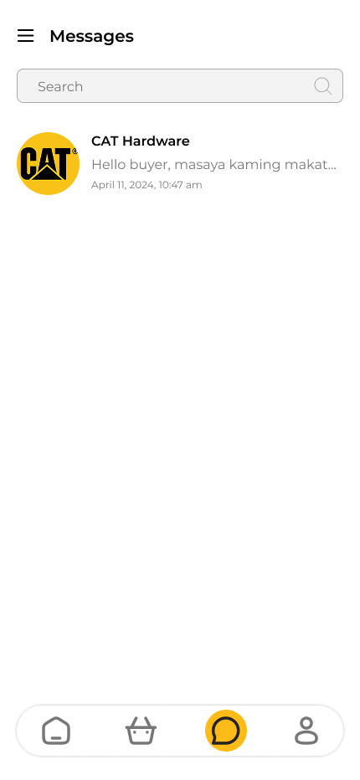

|  | Name | Description | Parameter | Action |
| --- | --- | --- | --- | --- |
| 42 | Search Field | EditText for searching messages. Contains placeholder text “Search” | android:hint="@string/placeholder_search_messages"  android:inputType="textAutoComplete" | On input, displays all the conversations matching the keyword |
| 43 | Messages RecyclerView | RecyclerView that displays all the conversations fetched | android:id="@+id/rvConversations"  app:layoutManager="LinearLayoutManager" |  |
| 44 | Conversation Container | LinearLayout that holds the conversation information | android:background="?selectableItemBackground"  android:orientation="horizontal" | Leads to Conversation Activity with chosen conversation information |
| 45 | Recipient Image - Conversation Container | ImageView that shows profile image of the recipient | android:contentDescription="@string/decor_recipient_image"  android:scaleType="centerCrop" |  |
| 46 | Recipient Name - Conversation Container | TextView that displays the name of recipient | android:textSize="16sp"  android:textStyle="bold"  android:textColor="@color/black" |  |
| 47 | Message Excerpt - Conversation Container | TextView that displays an excerpt of the last message sent/received | android:textSize="14sp"  android:maxLines="1"  android:ellipsize="end" |  |
| 48 | Message Timestamp - Conversation Container | TextView that shows time of when the message is sent | android:textSize="12sp"  android:textColor="@color/gray"  android:layout_gravity="end" |  |

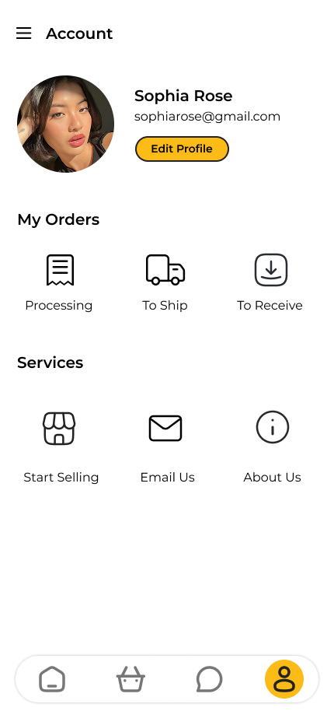

|  | Name | Description | Parameter | Action |
| --- | --- | --- | --- | --- |
| 49 | Account Image | ImageView that contains the user’s profile image | android:src="@drawable/default_profile"  android:contentDescription="@string/decor_profile_image"  android:clickable="true" | Opens a menu that lets users to take photo or choose image to replace their current profile image |
| 50 | Full Name | TextView that displays user’s full name | android:textSize="18sp"  android:textStyle="bold"  android:textColor="@color/black" |  |
| 51 | Email Address | TextView that displays user’s email address | android:textSize="14sp"  android:textColor="@color/gray" |  |
| 52 | Edit Profile Button | Yellow button with text “Edit Profile” | android:text="@string/btn_edit_profile"  android:background="@colors/primary" | Leads to Edit Profile Activity |
| 53 | My Orders | TextView for the view group | android:text="@string/decor_my_orders"  android:textStyle="bold" |  |
| 54 | Processing Image Button | ImageButton with receipt icon and text saying “Processing” | android:src="@drawable/ic_receipt"  android:text="@string/link_processing_orders" | Leads to Transaction History with Processing Filter |
| 55 | To Ship Image Button | ImageButton with delivery truck icon and text saying “To Ship” | android:src="@drawable/ic_delivery_truck"  android:text="@string/link_to_ship_orders" | Leads to Transaction History with To Ship Filter |
| 56 | To Receive Image Button | ImageButton with boxed arrow down icon and text saying “To Receive” | android:src="@drawable/ic_box_arrow_down"  android:text="@string/link_to_receive_orders" | Leads to Transaction History with To Receive Filter |
| 57 | Services | TextView for the view group | android:text="@string/decor_services"  android:textStyle="bold" |  |
| 58 | Start Selling Image Button | ImageButton with boxed arrow down icon and text saying “To Receive” | android:src="@drawable/ic_store"  android:text="@string/link_start_selling" | Leads to online website for vendors page |
| 59 | Email Us Image Button | ImageButton with boxed arrow down icon and text saying “Email Us” | android:src="@drawable/ic_email"  android:text="@string/link_email_us" | Leads to device’s primary email service’s email compose |
| 60 | About Us Image Button | ImageButton with boxed arrow down icon and text saying “About Us” | android:src="@drawable/ic_info"  android:text="@string/link_about_us" | Leads to online website’s about us page |

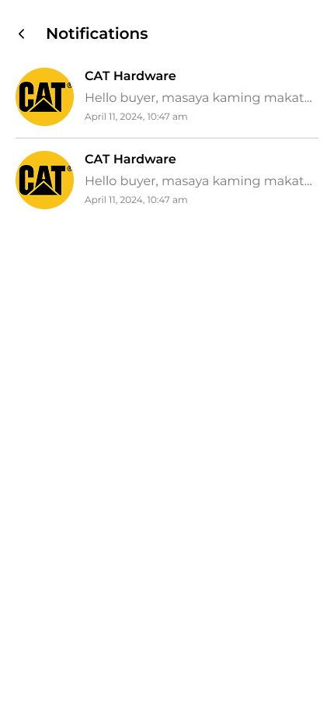

|  | Name | Description | Parameter | Action |
| --- | --- | --- | --- | --- |
| 61 | Notifications RecyclerView | RecyclerView that displays all the notifications fetched | android:id="@+id/rvNotifications"  app:layoutManager="LinearLayoutManager" |  |
| 62 | Notification Container | LinearLayout that holds the information of the notification | android:background="?selectableItemBackground"  android:orientation="horizontal" | Leads user to the appropriate screen depending on notif type |
| 63 | Sender Image | ImageView that contains the profile image of the user/shop/system triggering the notification | android:contentDescription="@string/decor_sender_image"  android:scaleType="centerCrop" |  |
| 64 | Sender Name | TextView that displays the name of the user/shop/system | android:textSize="14sp"  android:textStyle="bold" |  |
| 65 | Notification Details | TextView that displays the notification’s content | android:textSize="14sp"  android:maxLines="2"  android:ellipsize="end" |  |
| 66 | Notification Timestamp | TextView that shows time of when the notification is sent | android:textSize="12sp"  android:textColor="@color/gray" |  |

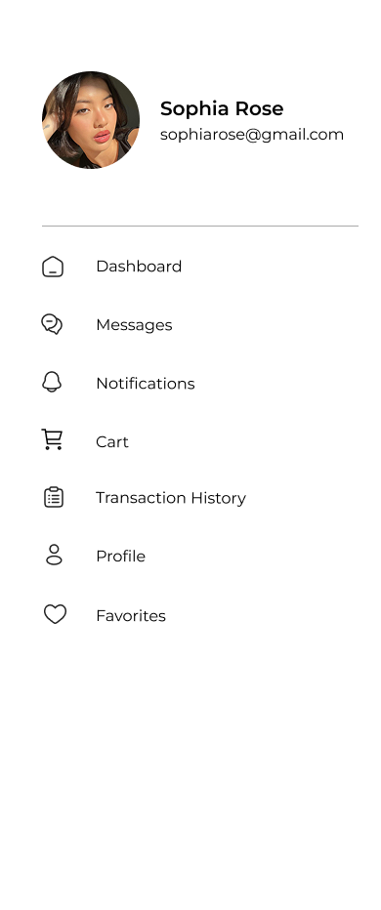

|  | Name | Description | Parameter | Action |
| --- | --- | --- | --- | --- |
| 67 | Account Image | ImageView that contains the user’s profile image | android:src="@drawable/default_profile"  android:contentDescription="@string/decor_profile_image"  android:layout_width="80dp"  android:layout_height="80dp" |  |
| 68 | Full Name | TextView that displays user’s full name | android:textSize="16sp"  android:textStyle="bold"  android:textColor="@color/black" |  |
| 69 | Email Address | TextView that displays user’s email address | android:textSize="14sp"  android:textColor="@color/gray" |  |
| 70 | Dashboard | ListView Item containing an ImageView of home icon and TextView with text “Dashboard” | android:icon="@drawable/ic_home"  android:title="@string/link_dashboard" | Leads to Dashboard Screen |
| 71 | Messages | ListView Item containing an ImageView of home icon and TextView with text “Messages” | android:icon="@drawable/ic_message"  android:title="@string/link_messages" | Leads to Messages Screen |
| 72 | Notifications | ListView Item containing an ImageView of bell icon and TextView with text “Notifications” | android:icon="@drawable/ic_bell"  android:title="@string/link_notifications" | Leads to Notification Activity |
| 73 | Cart | ListView Item containing an ImageView of cart icon and TextView with text “Cart” | android:icon="@drawable/ic_cart"  android:title="@string/link_cart" | Leads to Cart Activity |
| 74 | Transaction History | ListView Item containing an ImageView of home icon and TextView with text “Transaction History” | android:icon="@drawable/ic_receipt"  android:title="@string/link_transaction_history" | Leads to Transaction History Activity |
| 75 | Profile | ListView Item containing an ImageView of home icon and TextView with text “Profile” | android:icon="@drawable/ic_user"  android:title="@string/link_profile" | Leads to Account Screen |
| 76 | Favorites | ListView Item containing an ImageView of home icon and TextView with text “Favorites” | android:icon="@drawable/ic_user"  android:title="@string/link_favpritess" | Leads to Favorites Activity |

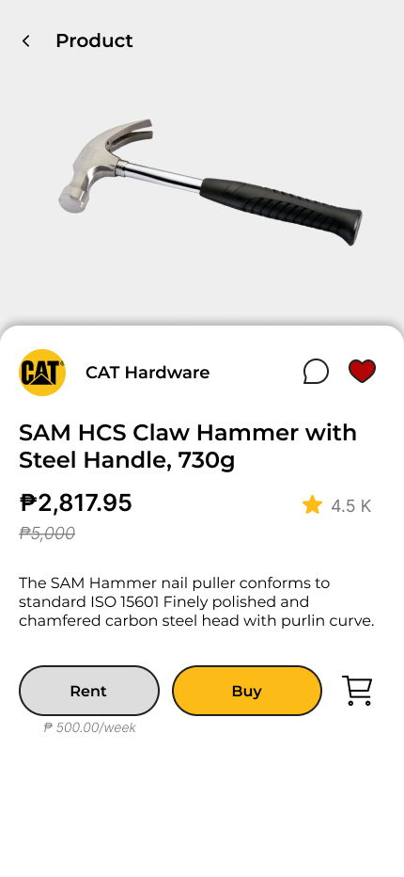

|  | Name | Description | Parameter | Action |
| --- | --- | --- | --- | --- |
| 77 | Product Image | ImageView that contains the product image | android:scaleType="centerCrop"  android:contentDescription="@string/decor_product_image" |  |
| 78 | Shop Image | ImageView that contains the shop’s profile image | android:src="@drawable/default_shop"  android:contentDescription="@string/decor_shop_image" |  |
| 79 | Shop Name | TextView that displays shop’s name | android:textSize="14sp"  android:textStyle="bold" |  |
| 80 | Messages Button | ImageButton with message bubble icon | android:src="@drawable/ic_message"  android:contentDescription="@string/link_contact_seller" | Leads to Conversation Activity of user’s and shop’s |
| 81 | Add to Favorites Button | ImageButton with heart icon | android:src="@drawable/ic_heart_outline"  android:contentDescription="@string/btn_toggle_favorite" | Adds product to Favorites and turns icon to red |
| 82 | Product Name | TextView that displays the product name | android:textSize="18sp"  android:textStyle="bold" |  |
| 83 | Product Price | TextView that shows product price | android:textSize="16sp"  android:textColor="@colors/primary" |  |
| 84 | Product Original Price | TextView with strikethrough line that shows product’s original price before the current price | android:textSize="14sp"  android:paintFlags="strikeThruText" |  |
| 85 | Product Description | TextView which contains the description of the product | android:textSize="14sp"  android:lineSpacingExtra="4dp" |  |
| 86 | Rent Button | Gray button with text “Rent” | android:text="@string/btn_rent"  android:background="@color/mono_lgray" | Shows rent form |
| 87 | Rent Per Period | TextView that displays the rent rate of the product per period of time | android:textSize="12sp"  android:textColor="@color/gray" |  |
| 88 | Buy Button | Yellow button with text “Buy” | android:text="@string/btn_buy"  android:background="@colors/primary" | Shows buy form |
| 89 | Add to Cart Button | ImageButton with cart icon | android:src="@drawable/ic_cart_add"  android:contentDescription="@string/btn_add_to_cart" | Adds product to cart |

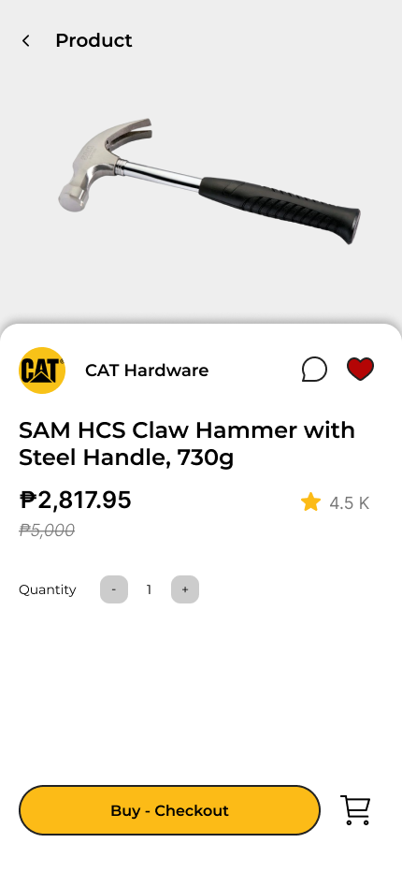

|  | Name | Description | Parameter | Action |
| --- | --- | --- | --- | --- |
| 90 | Quantity | TextView with text “Quantity” | android:text="@string/label_quantity"  android:textSize="14sp" |  |
| 91 | Minus Button | ImageButton with minus sign | android:src="@drawable/ic_minus"  android:contentDescription="@string/btn_decrease_qty" | Decreases quantity of product to be ordered |
| 92 | Quantity Number | TextView that displays the current quantity of product to be ordered | android:text="1"  android:textSize="16sp"  android:minWidth="24dp" |  |
| 93 | Add Button | ImageButton with plus sign | android:src="@drawable/ic_plus"  android:contentDescription="@string/btn_increase_qty" | Increases quantity of product to be ordered |
| 94 | Buy - Checkout Button | Yellow button with text “Buy - Checkout” | android:text="@string/btn_buy_checkout"  android:background="@colors/primary" | Proceeds to checkout the product |
| 95 | Add to Cart Button | ImageButton with cart icon | android:src="@drawable/ic_cart_add"  android:contentDescription="@string/btn_add_to_cart" | Adds the product to cart with the quantity and buy state |

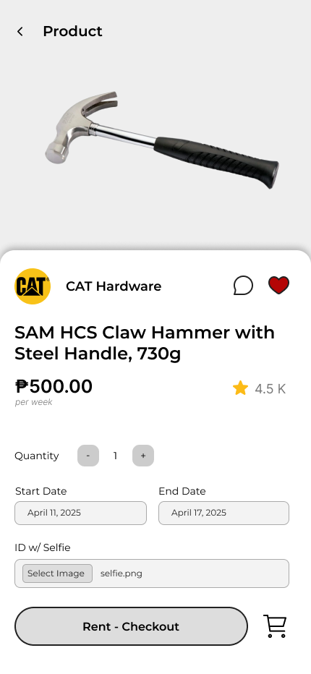

|  | Name | Description | Parameter | Action |
| --- | --- | --- | --- | --- |
| 96 | Quantity | TextView with text “Quantity” | android:text="@string/label_quantity"  android:textSize="14sp" |  |
| 97 | Minus Button | ImageButton with minus sign | android:src="@drawable/ic_minus"  android:contentDescription="@string/btn_decrease_qty"  android:enabled="false" (when qty=1) | Decreases quantity of product to be ordered |
| 98 | Quantity Number | TextView that displays the current quantity of product to be ordered | android:text="1"  android:textSize="16sp"  android:minWidth="24dp" |  |
| 99 | Add Button | ImageButton with plus sign | android:src="@drawable/ic_plus"  android:contentDescription="@string/btn_increase_qty" | Increases quantity of product to be ordered |
| 100 | Start Date Field | DatePicker for the start date of rent | android:hint="@string/placeholder_start_date"  android:inputType="date" | Opens a datepicker |
| 101 | End Date Field | DatePicker for the end date of rent | android:hint="@string/placeholder_end_date"  android:inputType="date" | Opens a datepicker |
| 102 | ID w/ Selfie Field | Button and TextView for ID w/ Selfie | Button: android:text="@string/btn_upload_id"  TextView: android:text="" | On upload, the text view changes to the filename of the file uploaded |
| 103 | Buy - Checkout Button | Yellow button with text “Buy - Checkout” | android:text="@string/btn_buy_checkout"  android:background="@colors/primary" | Proceeds to checkout the product |
| 104 | Add to Cart Button | ImageButton with cart icon | android:src="@drawable/ic_cart_add"  android:contentDescription="@string/btn_add_to_cart" | Adds the product to cart with the quantity and buy state |

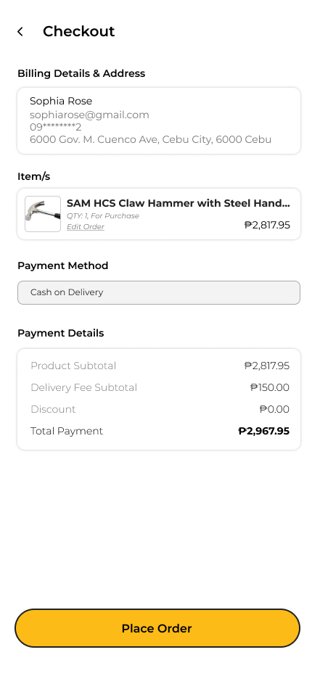

|  | Name | Description | Parameter | Action |
| --- | --- | --- | --- | --- |
| 105 | Billing Details and Address | TextView labeling the view group | android:text="@string/decor_billing_details"  android:textStyle="bold" |  |
| 106 | Full Name | TextView for customer’s name | android:textSize="14sp" |  |
| 107 | Email Address | TextView for customer’s email address | android:textSize="14sp" |  |
| 108 | Contact Number | TextView for customer’s contact number | android:textSize="14sp" |  |
| 109 | Address | TextView for customer’s address | android:textSize="14sp"  android:maxLines="2" |  |
| 110 | Item/s | TextView labeling the view group | android:text="@string/decor_order_items"  android:textStyle="bold" |  |
| 111 | Products ListView | ListView containing all the products for checkout | android:divider="@color/divider_gray"  android:dividerHeight="1dp" |  |
| 112 | Product Name | TextView that displays the product name | android:textSize="14sp"  android:textStyle="bold" |  |
| 113 | Product Order Details | TextView displaying concise details of the product ordered | android:textSize="12sp" |  |
| 114 | Edit Order Button | Button with text “Edit Order” | android:text="@string/btn_edit_order"  android:textColor="@colors/primary" | Lead’s to product buy/rent form |
| 115 | Single Product Order Total | TextView that displays the total price of product multiplied by quantity ordered | android:textSize="14sp"  android:textStyle="bold" |  |
| 116 | Payment Method | TextView labeling the view group | android:text="@string/decor_payment_method"  android:textStyle="bold" |  |
| 117 | Payment Method Spinner | Spinner for choosing Payment method | android:entries="@array/payment_methods"  android:prompt="@string/prompt_payment_method" | Opens payment method options |
| 118 | Payment Method | TextView labeling the view group | android:text="@string/decor_payment_summary" |  |
| 119 | Product Subtotal | TextView for the total of ordered products’ cost | android:textSize="14sp" |  |
| 120 | Delivery Fee Subtotal | TextView for delivery cost | android:textSize="14sp" |  |
| 121 | Discount | TextView for discount applied | android:textColor="@color/green" |  |
| 122 | Total Payment | Bold TextView that displays the final amount to be paid | android:textSize="16sp"  android:textStyle="bold" |  |
| 123 | Place Order Button | Yellow button with text “Place Order” | android:text="@string/btn_place_order"  android:background="@colors/primary" | Sends order to the system |

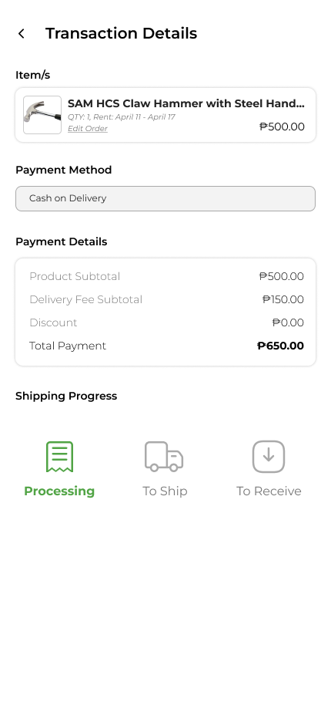

| **#** | **Name** | **Description** | **Parameter** | **Action** |
| --- | --- | --- | --- | --- |
| 124 | Products ListView | ListView containing all the products for checkout | android:id="@+id/lvOrderItems"  android:divider="@color/divider_gray" |  |
| 125 | Product Name | TextView that displays the product name | android:textSize="16sp"  android:textStyle="bold" |  |
| 126 | Product Order Details | TextView displaying concise details of the product ordered | android:textSize="14sp"  android:textColor="@color/gray" |  |
| 127 | Edit Order Button | Button with text “Edit Order” | android:text="@string/btn_edit_order"  android:textColor="@colors/primary" | Lead’s to product buy/rent form |
| 128 | Single Product Order Total | TextView that displays the total price of product multiplied by quantity ordered | android:textSize="16sp"  android:textStyle="bold" |  |
| 129 | Payment Method | TextView labeling the view group | android:text="@string/decor_payment_method"  android:textStyle="bold" |  |
| 130 | Product Subtotal | TextView for the total of ordered products’ cost | android:textSize="14sp" |  |
| 131 | Delivery Fee Subtotal | TextView for delivery cost | android:textSize="14sp" |  |
| 132 | Discount | TextView for discount applied | android:textColor="@color/green" |  |
| 133 | Total Payment | Bold TextView that displays the final amount to be paid | android:textSize="18sp"  android:textStyle="bold" |  |
| 134 | Shipping Progress | TextView for order status. Indicates the current stage of order fulfillment (e.g., Processing). | android:text="@string/status_processing"  android:textColor="@colors/primary" |  |
| 135 | To Ship Indicator | TextView or Progress Step. Shows that the order is pending shipment | android:text="@string/status_to_ship"  android:textColor="@color/gray" | . |
| 136 | To Receive Indicator | TextView or Progress Step.  Shows that the order is pending delivery. | android:text="@string/status_to_receive"  android:textColor="@color/gray" |  |

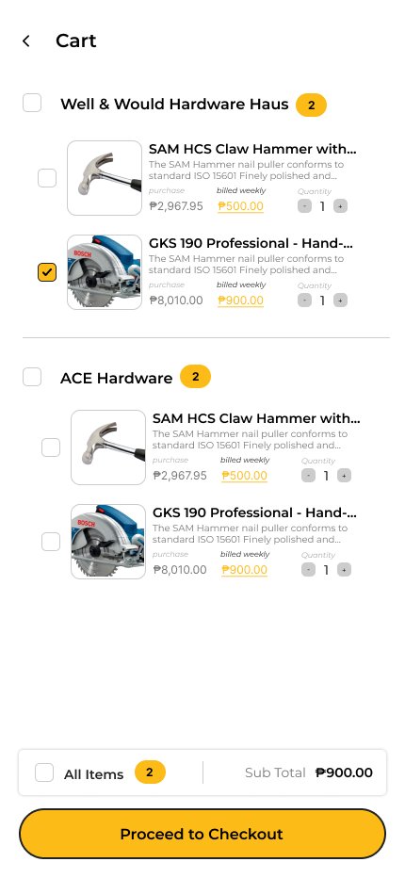

| **#** | **Name** | **Description** | **Parameter** | **Action** |
| --- | --- | --- | --- | --- |
| 137 | Store Checkbox | Checkbox for store selection | android:id="@+id/cbStore"  android:buttonTint="@colors/primary" | Toggles selection of all items under the store. |
| 138 | Product Name | TextView that displays the product name | android:textSize="16sp"  android:textStyle="bold" |  |
| 139 | Product Description | TextView displaying excerpt of the details of the product | android:textSize="12sp"  android:maxLines="2" |  |
| 140 | Purchase Text Button | Button & TextView indicating purchase/buy type and buy price | android:text="@string/btn_purchase"  style="@style/OrderTypeButton" | Changes order type to buy on tap, turns buy price to yellow |
| 141 | Rent Text Button | Button & TextView indicating rent type and rent price per rent period | android:text="@string/btn_rent"  style="@style/OrderTypeButton" | Changes order type to rent on tap, turns rent price to yellow |
| 142 | Quantity Selector | Buttons & TextView that controls/displays order quantity for the product | [ - 1 + ] layout  android:minWidth="24dp" | Increases/decreases item quantity. |
| 143 | All Items Toggle | Button to select/deselect all items | android:text="@string/btn_select_all" | Toggles selection of all cart items. |
| 144 | Item Count | Displays total selected items | android:textSize="14sp"  format="@string/format_item_count" |  |
| 145 | Subtotal Label | Displays aggregated cost | android:textSize="16sp"  android:textStyle="bold" |  |
| 146 | Checkout Button | Yellow button that says “Proceed to Checkout” | android:text="@string/btn_proceed_checkout"  android:background="@colors/primary" | Leads to Checkout Activity with products selected |

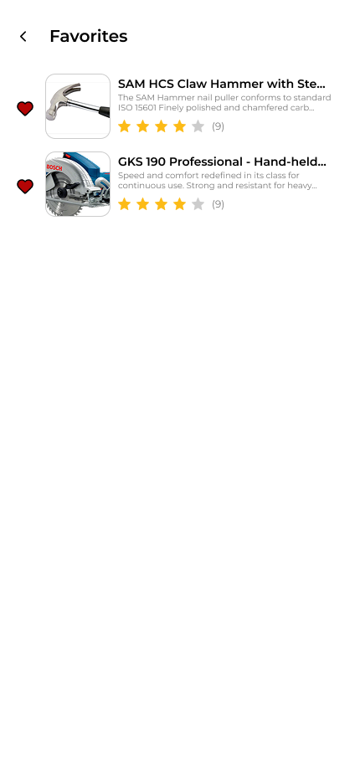

| **#** | **Name** | **Description** | **Parameter** | **Action** |
| --- | --- | --- | --- | --- |
| 147 | Favorite Products’ RecyclerView | RecyclerView for displaying all favorited products fetched | android:id="@+id/rvFavProds"  app:layoutManager="LinearLayoutManager" |  |
| 148 | Product ListItem | LinearLayout for containing all product information | android:background="?selectableItemBackground"  android:orientation="horizontal" |  |
| 149 | Heart Button | ImageButton with the heart icon | android:src="@drawable/ic_heart_outline"  android:contentDescription="@string/btn_toggle_favorite" | Asks for confirmation, then removes product from favorites |
| 150 | Product Image | ImageView that contains the product image | android:scaleType="centerCrop"  android:contentDescription="@string/decor_product_image" |  |
| 151 | Product Description | TextView displaying excerpt of the details of the product | android:textSize="12sp"  android:maxLines="2" |  |
| 152 | Product Star Ratings - Product Container | ImageView of star icons that show the average star rating of product | android:src="@drawable/ic_stars_4" (dynamic) |  |
| 153 | Product Feedback Counter- Product Container | TextView that shows how many users rated the product | android:textSize="12sp"  android:textColor="@color/gray" |  |

Test Plan

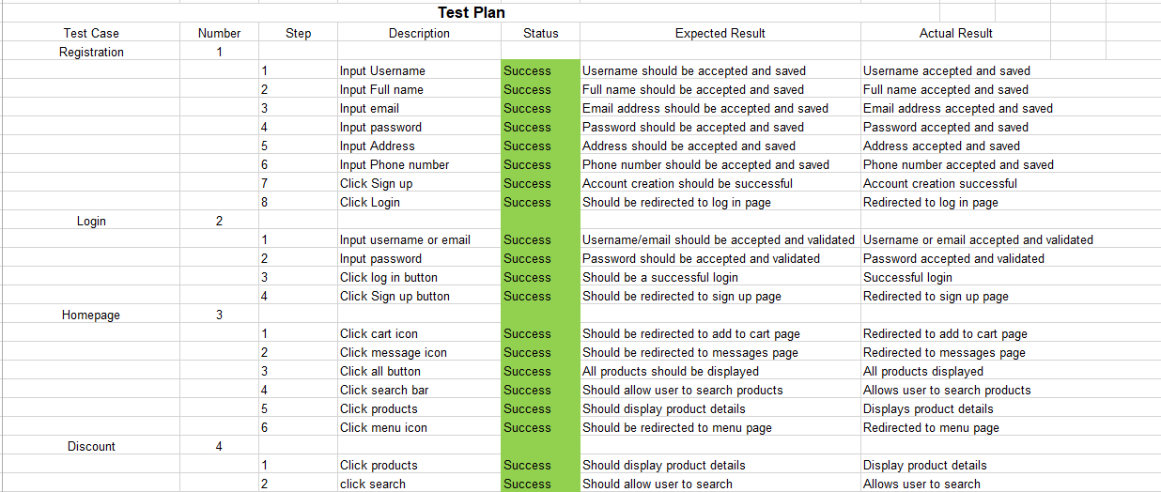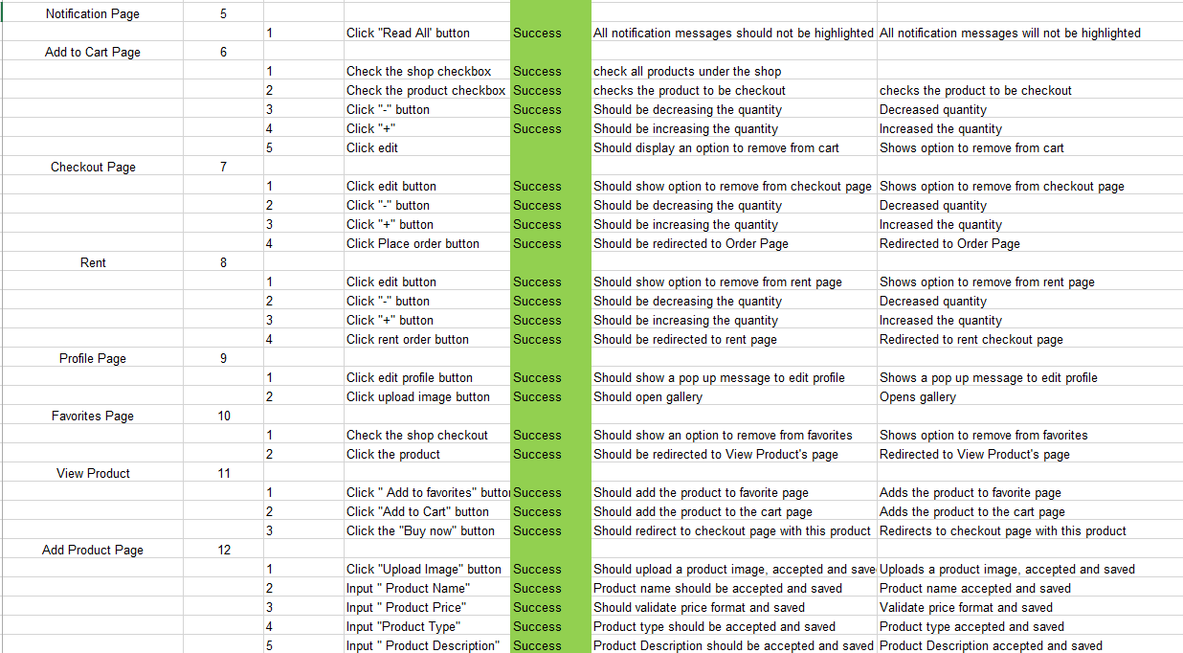

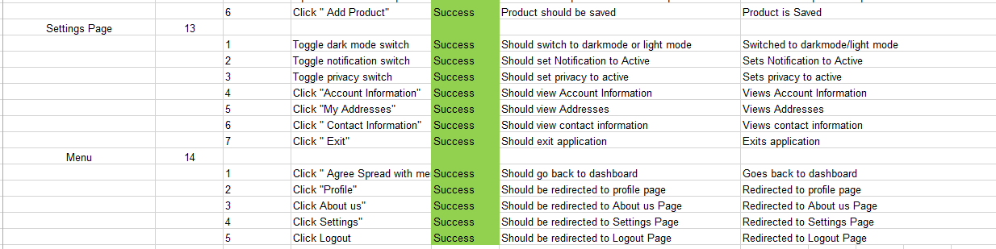

**Sequence Diagram**

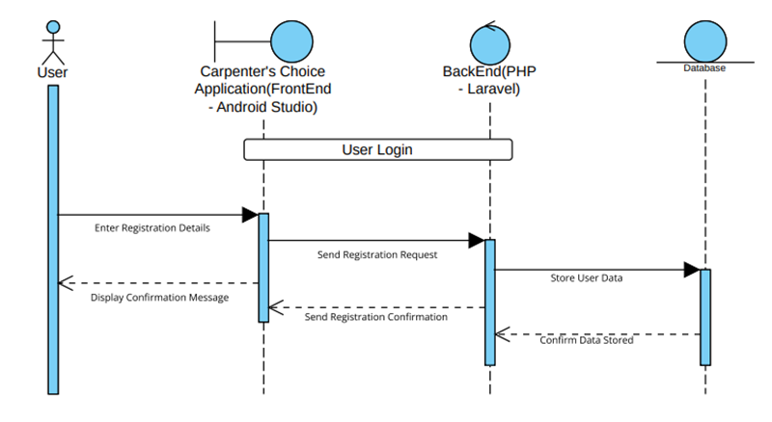

Registration Page

User Login

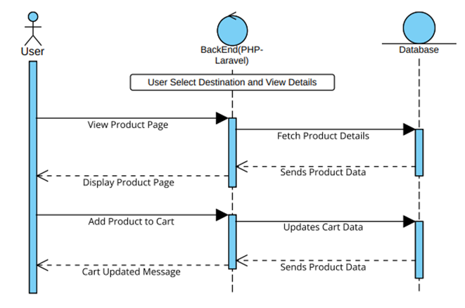

User Select Destination and View Details

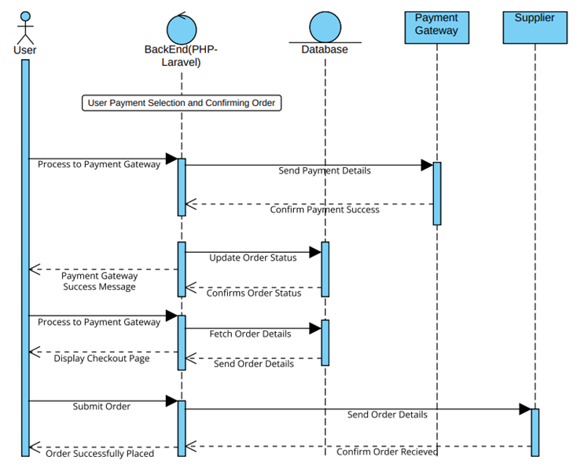

User Payment Selection and Confirming Order